CS401 MPP Final Exam

Name:__________________________ StudentId:___________________________

|  |  |  |  |  |  |  |
| --- | --- | --- | --- | --- | --- | --- |
| **Problem 1**  **(10)** | **Problem 2**  **(10)** | **Problem 3**  **(10)** | **Problem 4**  **(10)** | **Problem 5**  **(10)** | **Problem 6**  **(10)** | **Problem 7 - SCI**  **(3)** |
|  |  |  |  |  |  |  |

**Problem 1. (10 points)** Take a look at the package prob1, and the class SampleProblem1. There, a lambda expression is given in the class-level comments. Inside the class, the lambda is typed, represented as a method reference, and as a static nested class. There is also an evaluator method that evaluates all three expressions at values 2, 7.   
  
Follow the same format and complete the code in the class file Problem 1 for the lambda   
 (Double x, Double y) -> x * y < x + y

**Problem 2. (10 points)** Use the code in the helperclasses package and the class diagram below to help you solve the following problem.

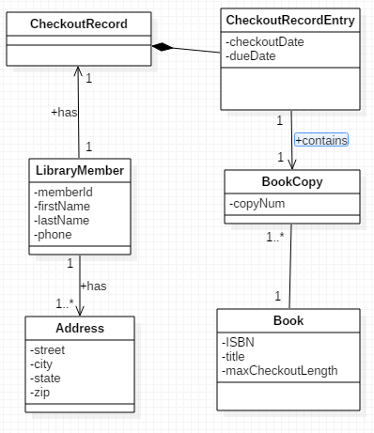

Write a stream pipeline inside the main method of the class Problem2 (in package prob2) that does the following: Print to the console the list of book titles –- in sorted order -- for which the book was checked out on June 27, 2015. The ordering of the book titles is as follows: First sort by the length

of the title (number of characters), then by alphabetical order.

Use the data provided in the TestData class – a call for the list of CheckoutRecordEntries provided in that class has already been made for you in the main method – use the list provided there.

**Problem 3. (10 points)** The Library is having a contest. Library members submit their ids so they can participate. The library will take a special list of books and go through the LibraryMember participants and, one by one, checkout the next available book on behalf of the next member in the participant list. If, during the process, a member is found who, in this checkout process, has just checked out his 10th book (that is, he now has exactly 10 CheckoutRecordEntries in his CheckoutRecord), he wins the contest.  
  
The code in prob3.Problem3 checks a list of LibraryMembers for a possible winner of the contest, using a List of books obtained from TestData. However, the code does not compile because the checkout method on LibaryMember is capable of throwing a LibrarySystemException and so this checked exception needs to be handled in the middle of a call to the current stream’s filter method.   
  
Use one of the standard techniques mentioned in class to fix this exception-handling problem so that the code compiles properly.

**Problem 4. (10 points)** *(The reduce operation)* Implement the static method called combine in your class Problem4 (in the package prob4) so that it transforms a Stream<ArrayList<T>> to an ArrayList<T> by joining all the lists of the stream together. Example: If these are the lists in the stream: [“Hello”, “there”], [“goodbye”, “again”], then the output of your combine method would be [“Hello”, “there”, “goodbye”, “again”].  
  
Your solution *must make use of the reduce method for Streams.*  
  
Test your solution by running the method testCombine that has been provided for you – this method is called from the main method in your class.

**Problem 5**. **(10 points)**  In your prob5 package, you will find three classes: Employee, Manager, LeadEngineer. Their relationships to each other are shown in the following class diagram:

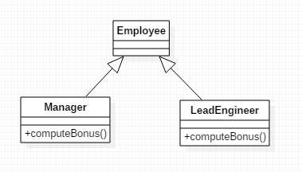

The computeBonus methods in the classes Manager and LeadEngineer have identical implementations in both classes. Without changing the inheritance relationships shown here, use new features in Java 8 to modify the implementation of these classes so that there is no duplication of code.

**Problem 6.**  **(10 points)** (*Generic programming*) In the code below, you see a method conditionalRemove, which removes from an ArrayList of Strings all those Strings that have length exactly equal to 5. Write the most general possible version of this method.

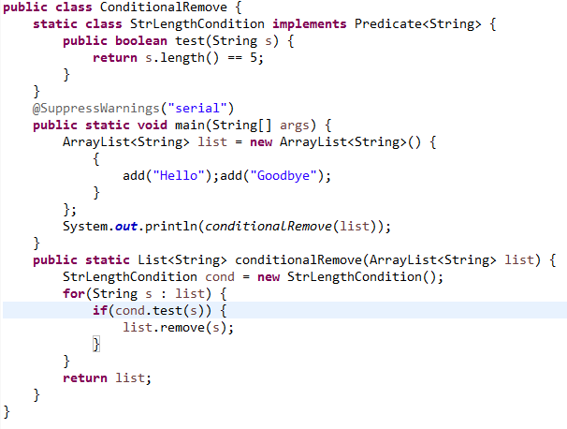

Things to generalize:

1. From String to the most general type possible
2. From the Predicate type shown in the sample code to the most general type of Predicate (you may need to include a Predicate as a second argument to your conditionalRemove method)

In a main method, show that your conditionalRemove is capable of

1. Removing all Strings in an ArrayList of Strings in which the letter ‘k’ occurs
2. Removing all Employees in an ArrayList of Employees whose salary is < 60,000
3. Remove all Integers in an ArrayList of Integers which are greater than 100

**Problem 7.** (**SCI – 3 points**) Write one or two paragraphs relating a point from the course to a principle from SCI.